**DAILY ONLINE ACTIVITIES SUMMARY**

|  |  |  |  |  |  |  |  |  |
| --- | --- | --- | --- | --- | --- | --- | --- | --- |
| **Date:** | **09/06/2020** | | | | | **Name:** | **RITIKA KULKARNI** | |
| **Sem& Sec** | **4thSEM. & ‘B’ SEC.** | | | | | **USN:** | **4AL19CS403** | |
| **Online Test Summary** | | | | | | | | |
| **Subject** | | **---** | | | | | | |
| **Max. Marks** | | **--** | | **Score** | | | **---** | |
| **Certification Course Summary** | | | | | | | | |
| **Course** | **Introduction of Information Security** | | | | | | | |
| **Certificate Provider** | | | **Greatlearning**  **Academy** | | **Duration** | | | **5 Hrs.** |
| **Coding Challenges** | | | | | | | | |
| **Problem Statement:**   1. **Rotate the matrix by K times means rotating the given NN matrix to the specified (K) number of times. For example, consider the 33 matrix, which has to be rotated once,**   **Enter the Size of the Matrix: 3, 3**  **Enter the Elements of the Matrix: 10, 20, 39, 40, 50, 60, 70, 80, 90**  **Enter the value of K (Number of Rotations): 1**  **Matrix before Rotation:**  **10 20 30**  **40 50 60**  **70 80 90**  **Matrix after Rotation:**  **20 30 10**  **50 60 40**  **80 90 70** | | | | | | | | |
| **Status: Executed** | | | | | | | | |
| **Uploaded the report in Github** | | | | | **Yes** | | | |
| **If yes Repository name** | | | | | <https://github.com/ritikakulkarni/QuarantineCoding-C_Coding> | | | |
| **Uploaded the report in slack** | | | | | **Yes** | | | |

**Certification Course Summary: Today, I have learnt about the Indroduction of Information Security, SQL Injection and Secure password which helps to execute the code and to achieve the output and some of the basic security commands.**

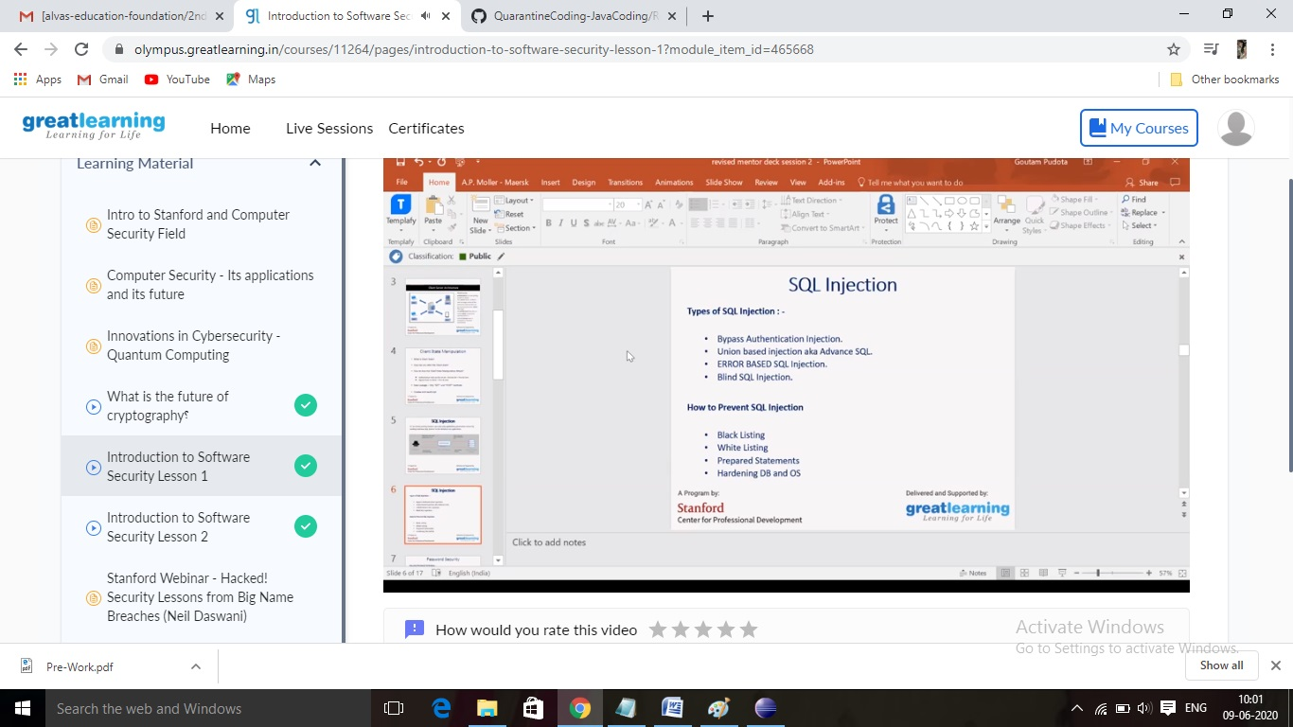

**Online Coding Summary:Online Coding Summary​: Online coding Summary: Today I received one program from Prof.Venkatesh CSE Dept. The program is mentioned above(pg.01). to my GitHub repository and I’ve shared the snapshot below.**

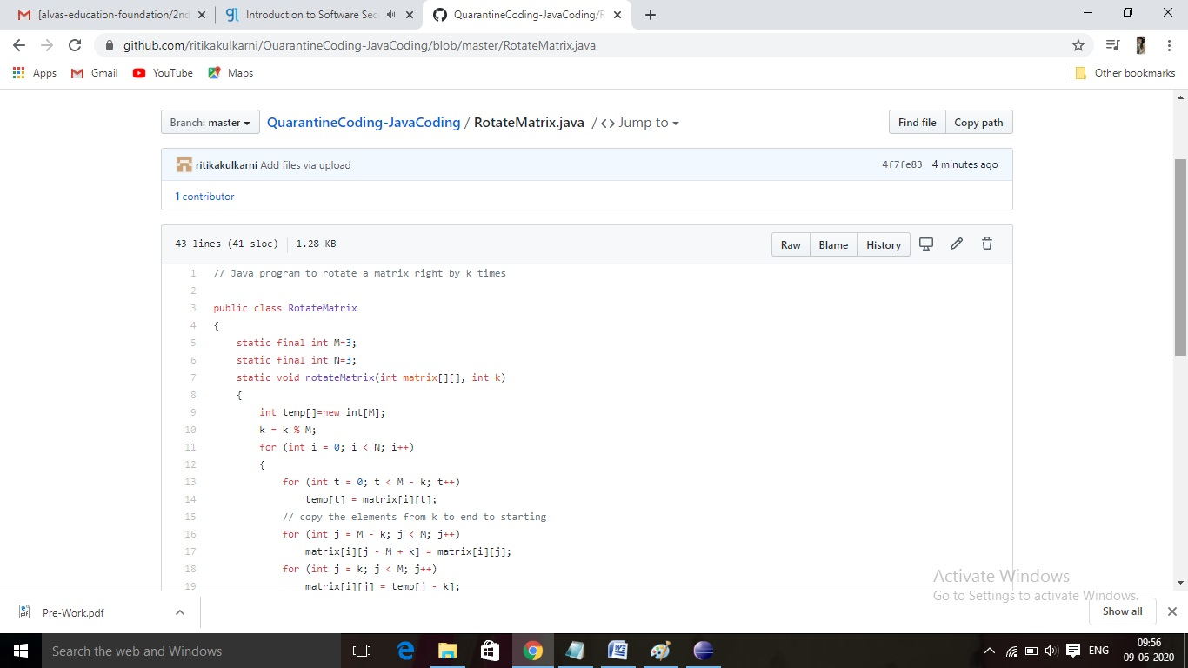

**Thank you.**